# Pytest POT:

# Reference:

[PyTest Tutorial For Beginners - Testing Framework For Python - YouTube](https://www.youtube.com/watch?v=snDSB9b8v_E)

[**https://www.youtube.com/watch?v=snDSB9b8v_E**](https://www.youtube.com/watch?v=snDSB9b8v_E)

# Basics:

File/tests/methods should start with test_ or end with _test

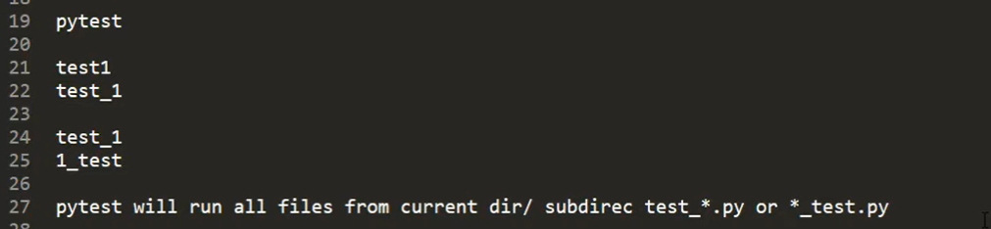

Type pytest in terminal to run all tests in folder

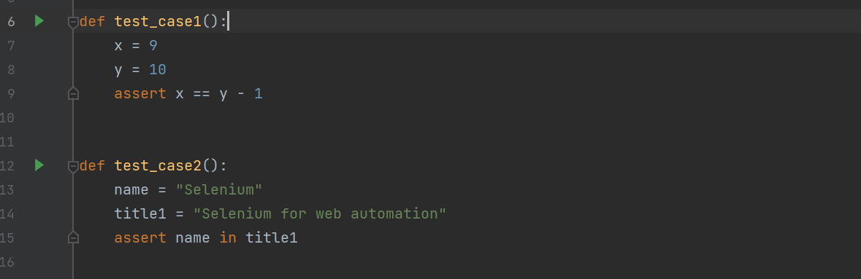

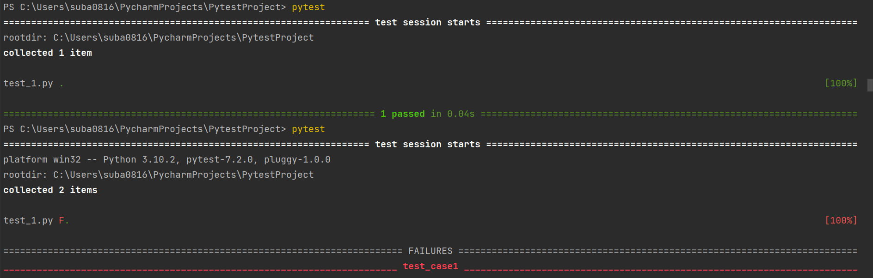

pytest –h for help screen

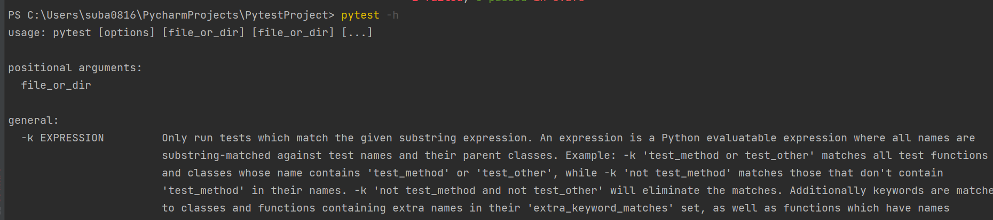

pytest -r prints extra test summary as specified by chars



pytest -rA prints details of all test cases like 2 passed, 1 failed

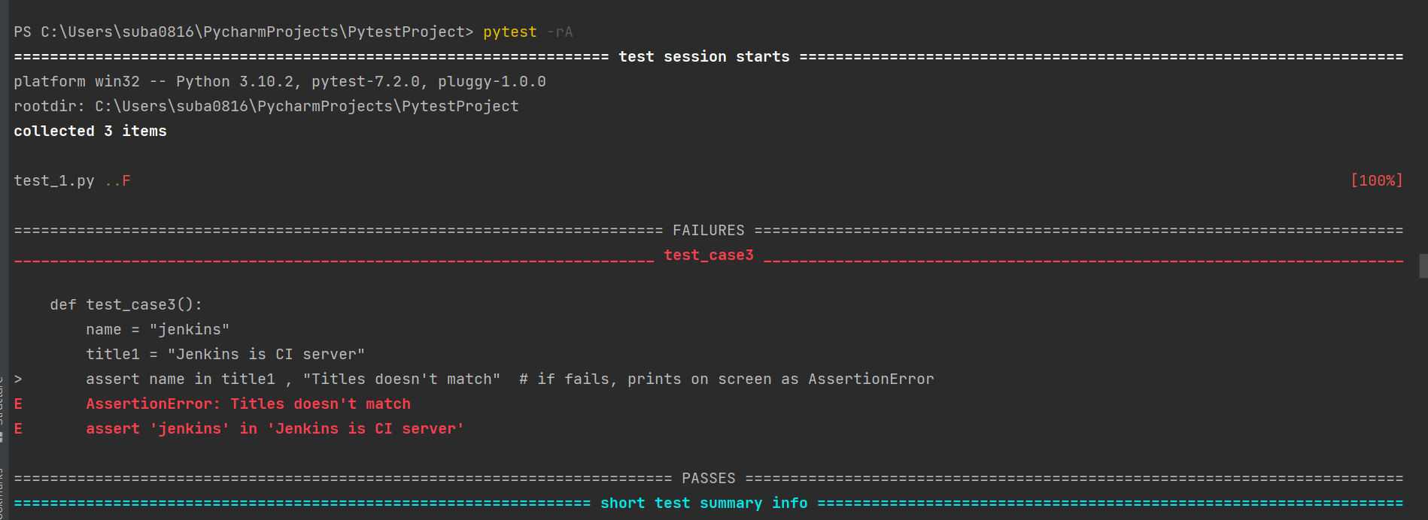

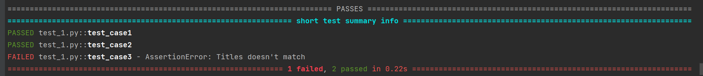

pytest --markers

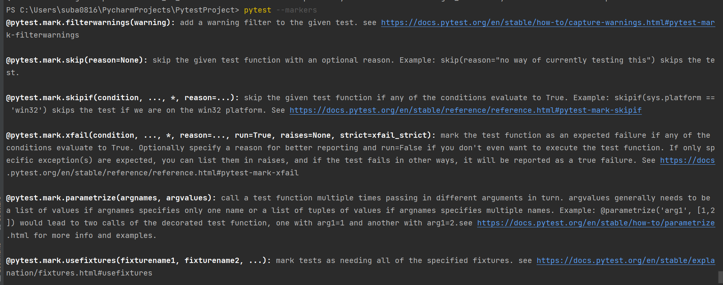

Pytest --fixtures

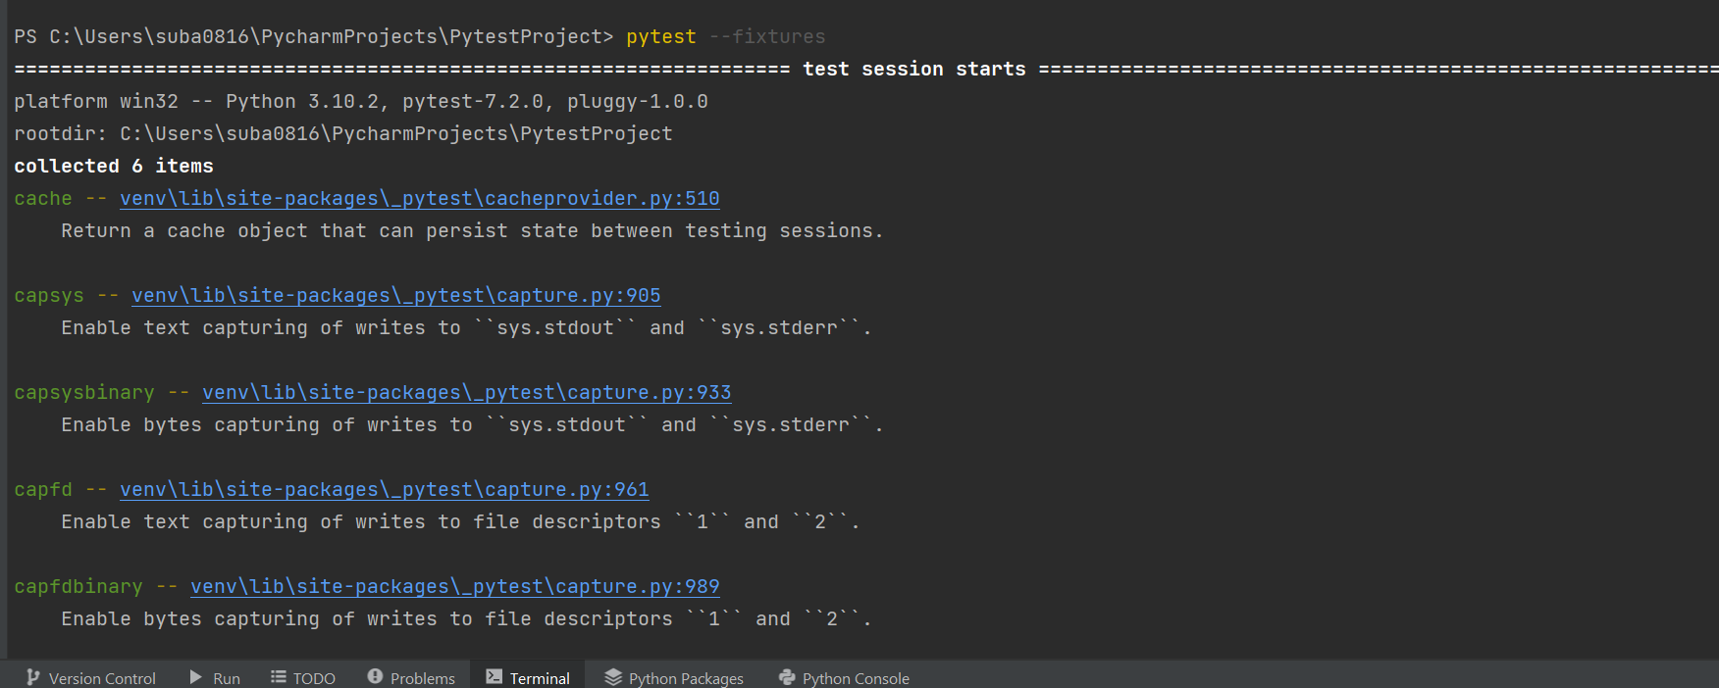

**Test_2:**

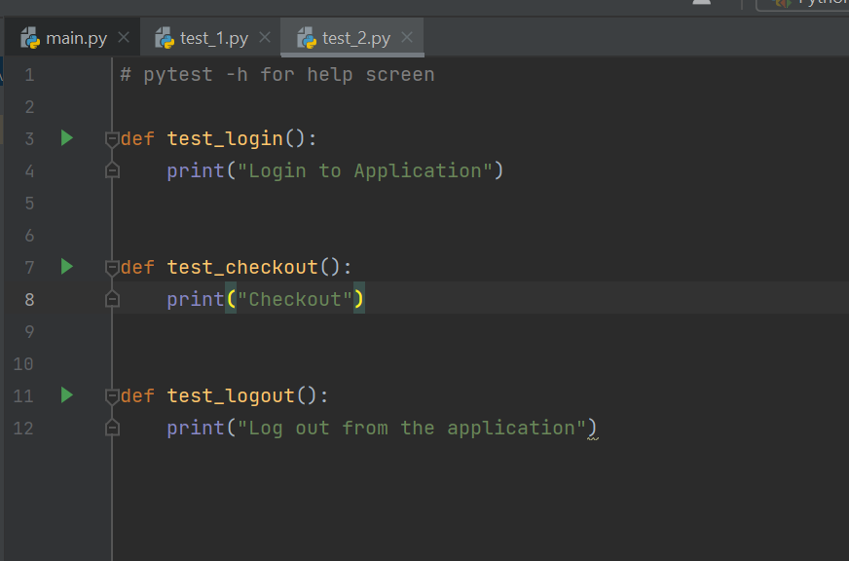

To run specific file 🡪 pytest file_name

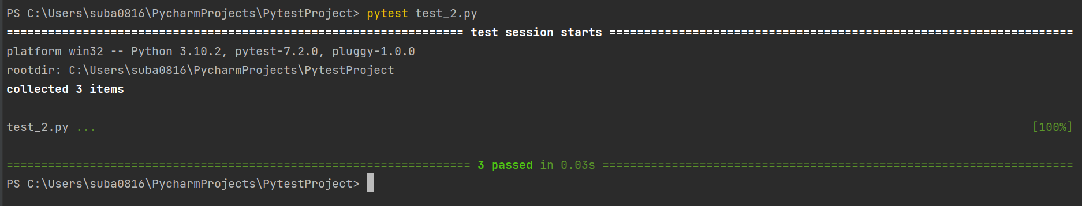

Run with –rA

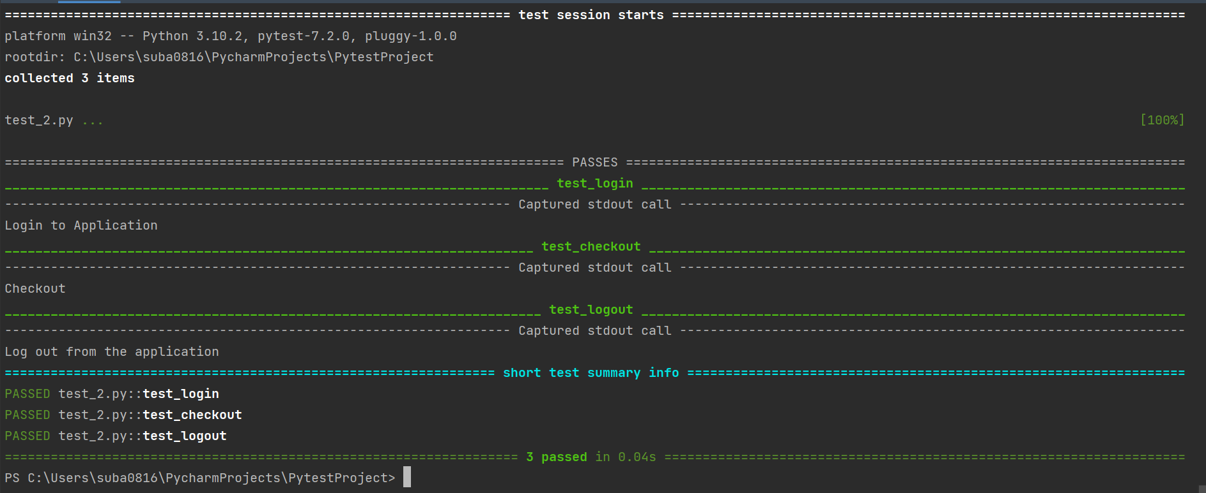

With –k 🡪 -k login

pytest –rA –k out

runs all test cases having out in name

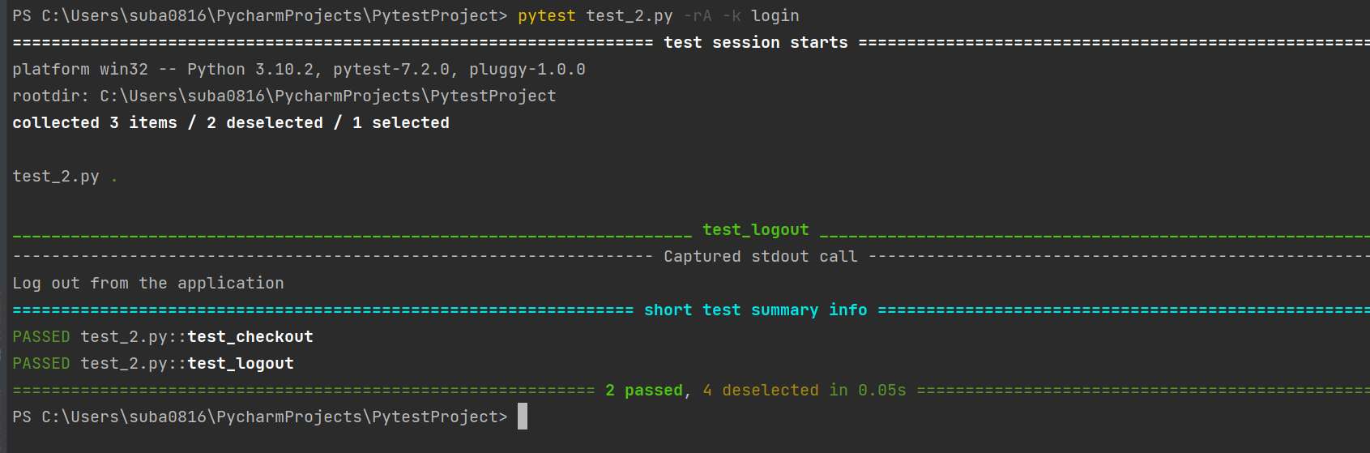

With –v 🡪means verbose

Prints short summary

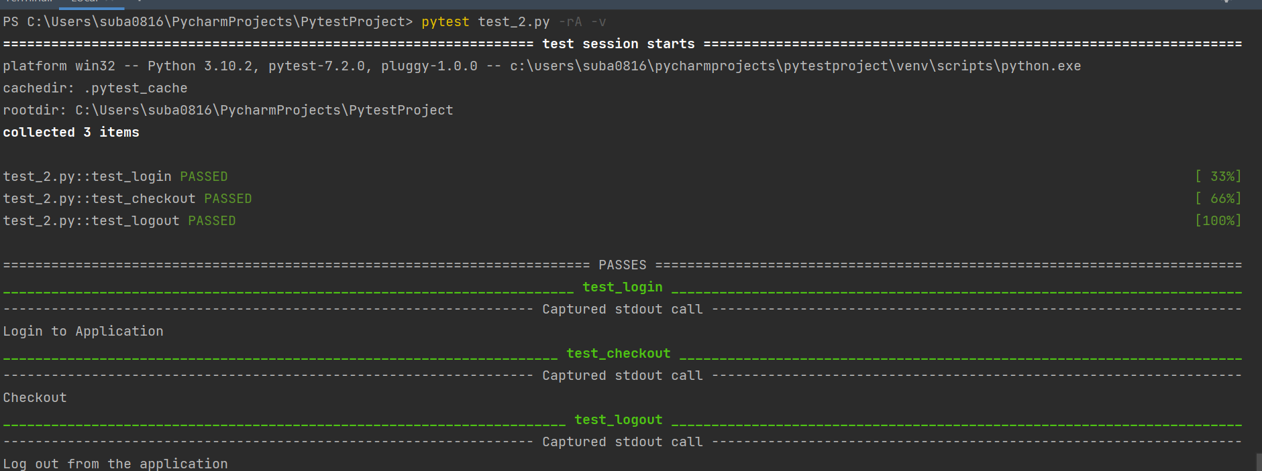

**Test_3 with unit test**

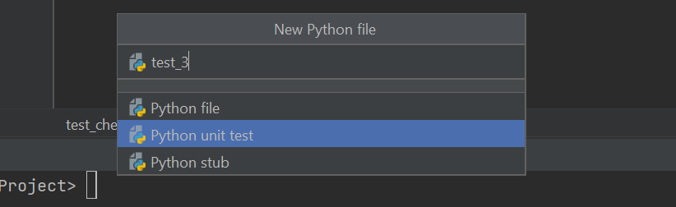

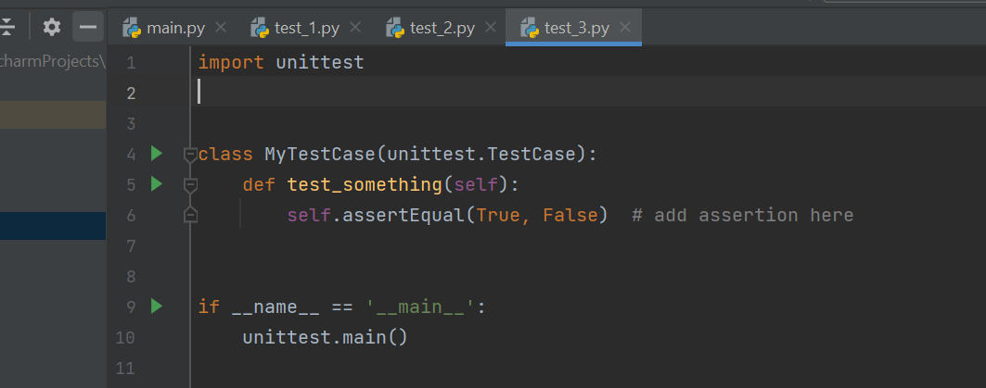

**Test_4**

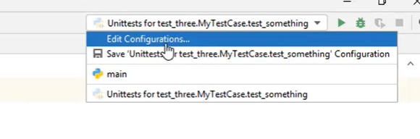

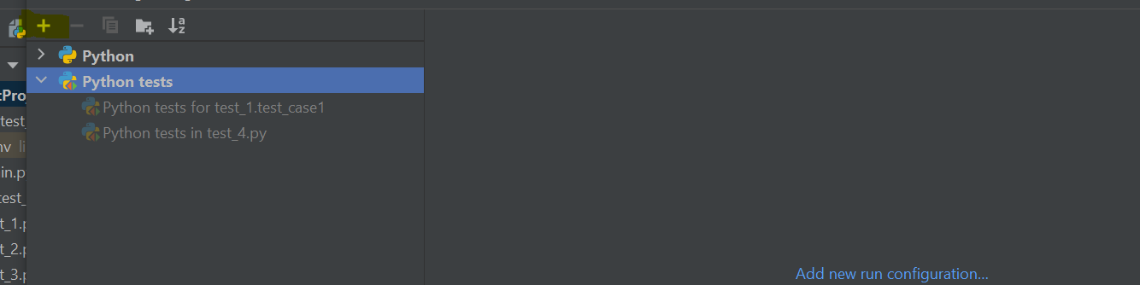

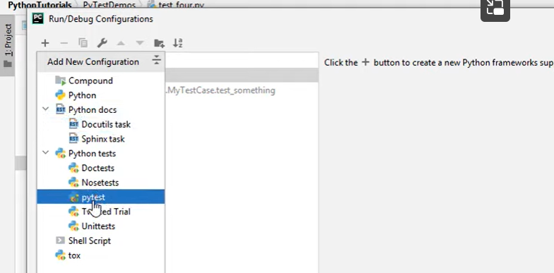

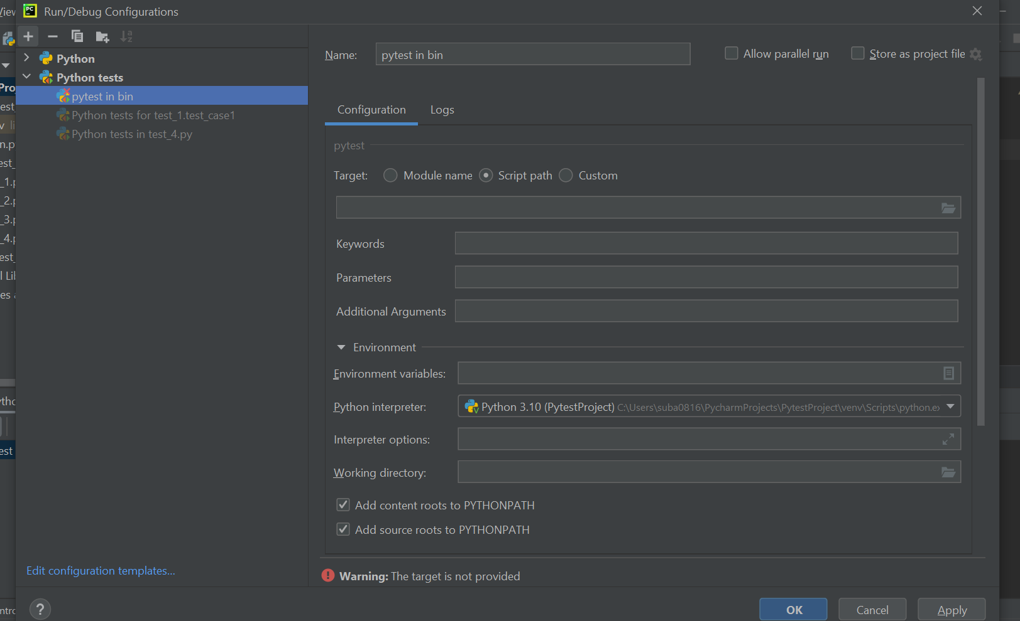

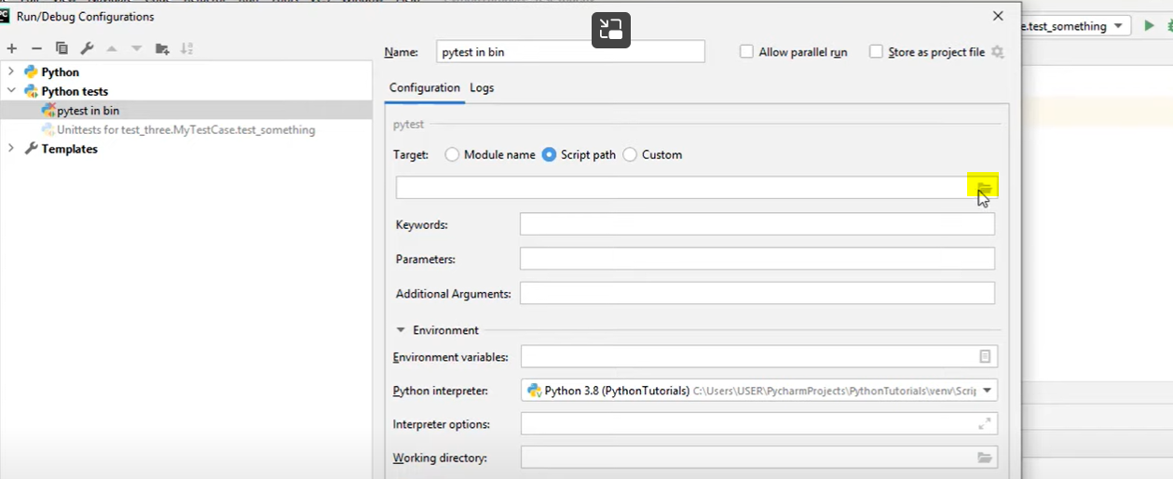

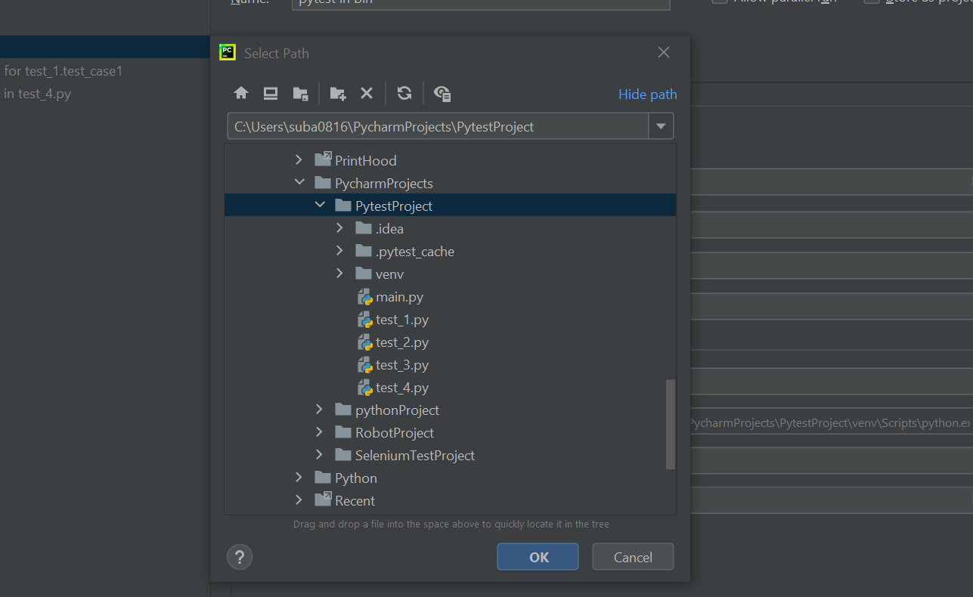

You will get option for pytest for

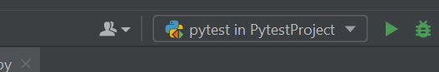

Run test from Run: (right click in program)

Used to debug locally (not preferred usually)

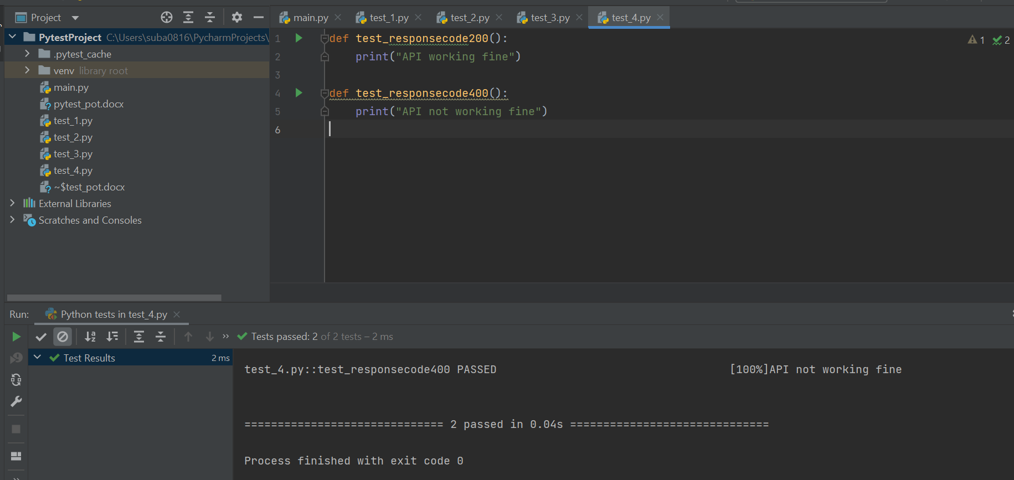

# Generating xml reports:

pytest -rA --jnunitxml="Report1.xml" 🡪 to dump report in xml file

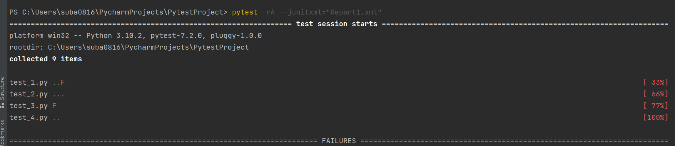

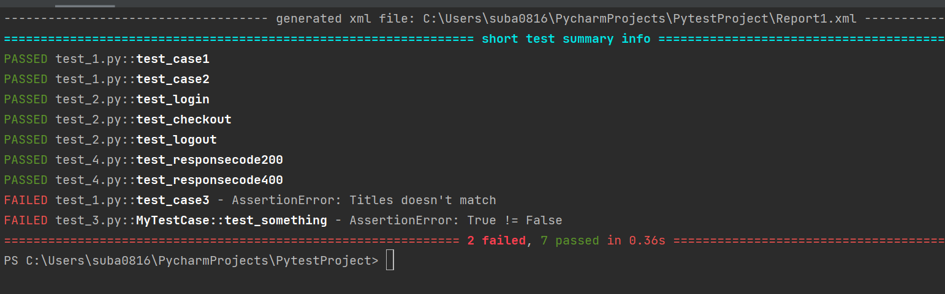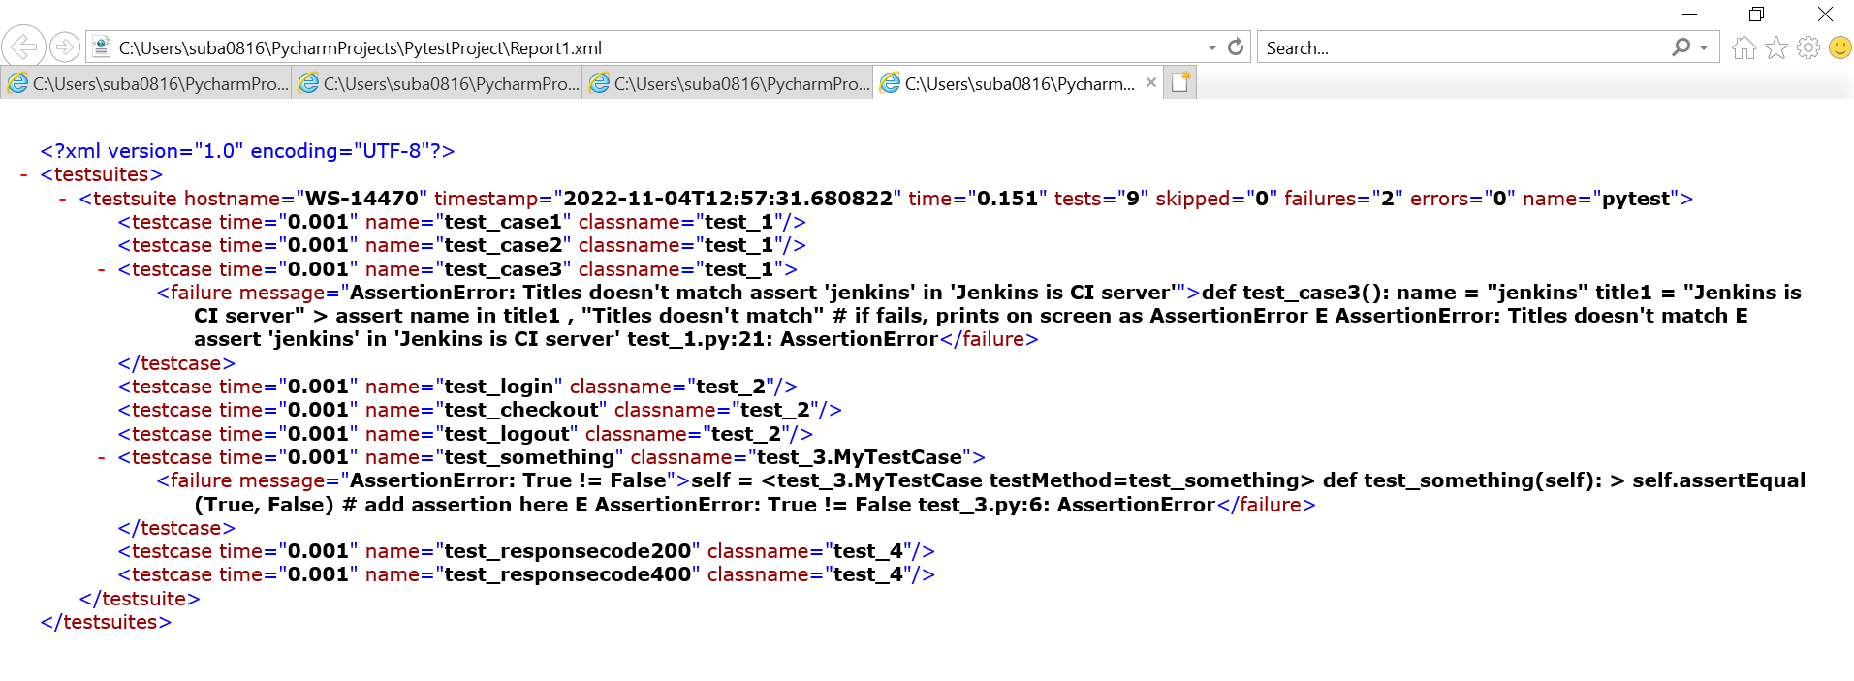

# Generating html reports:

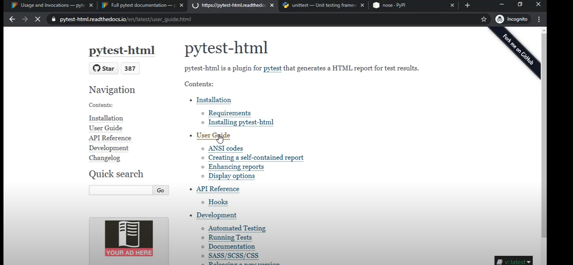

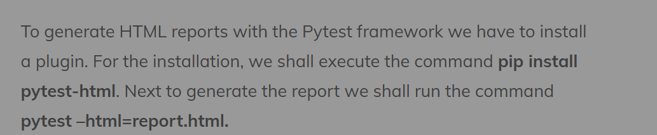

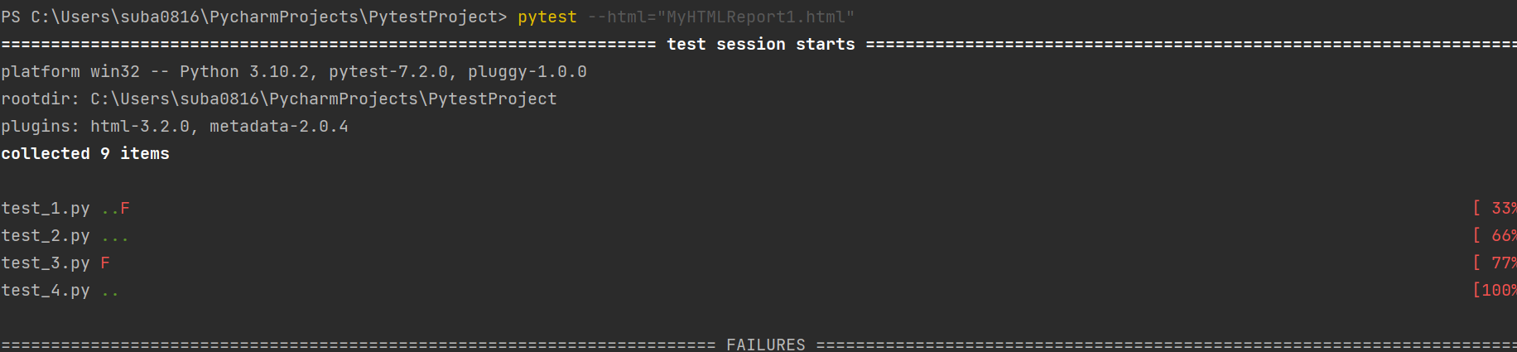

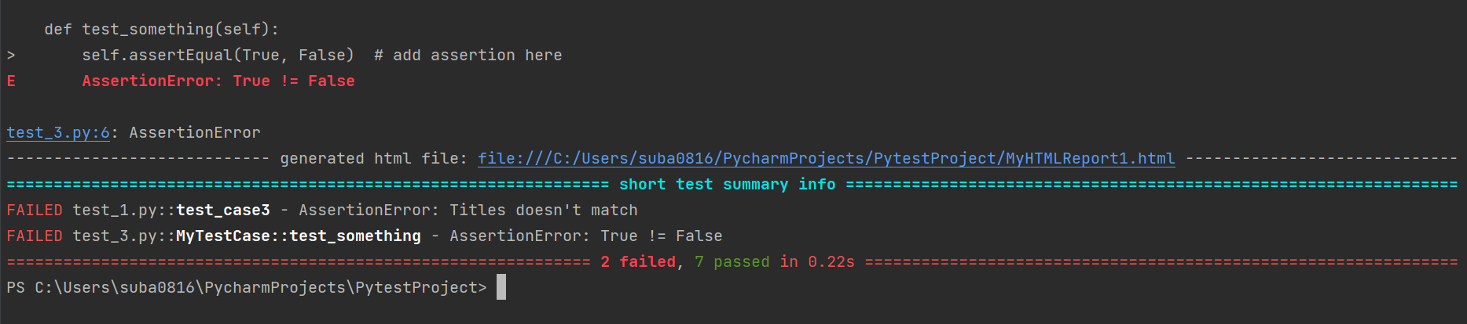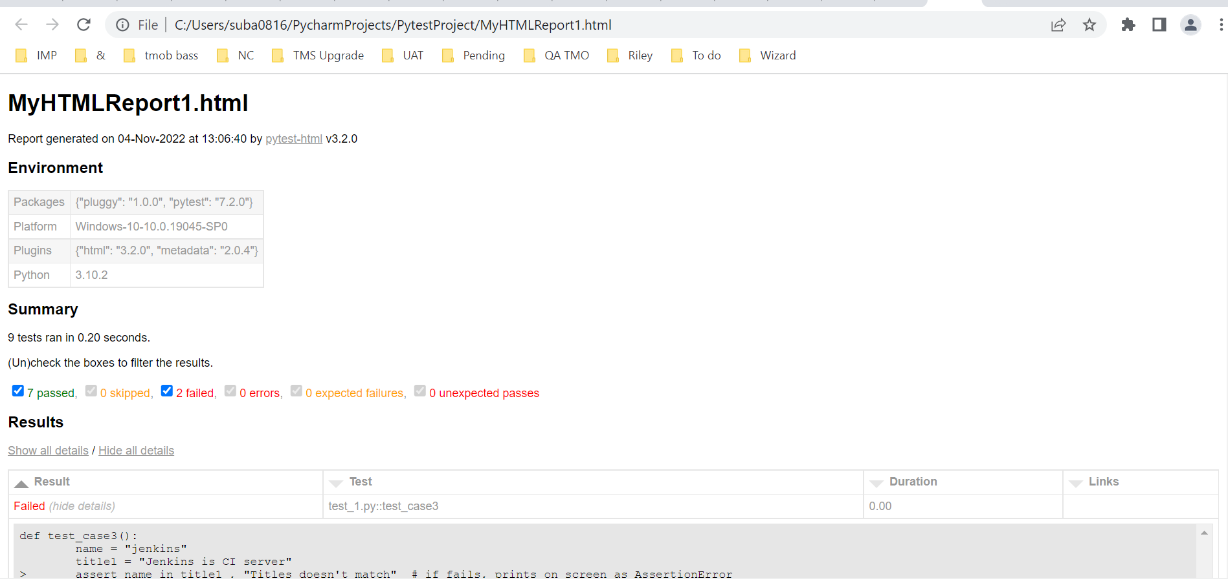

# Markers:

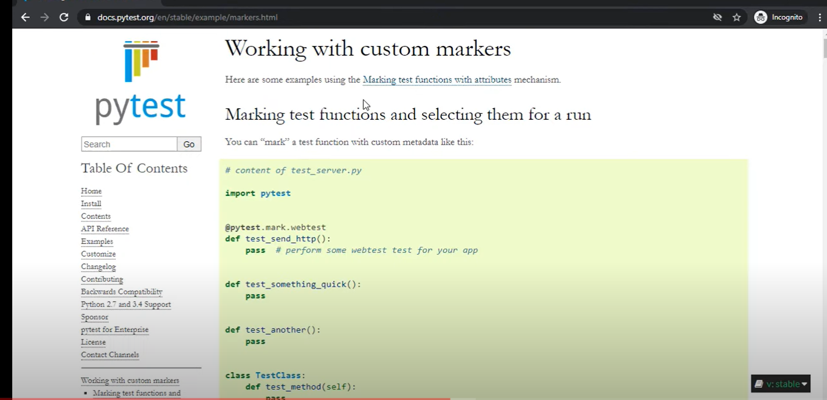

Markers used to provide additional info from a test

Test_5

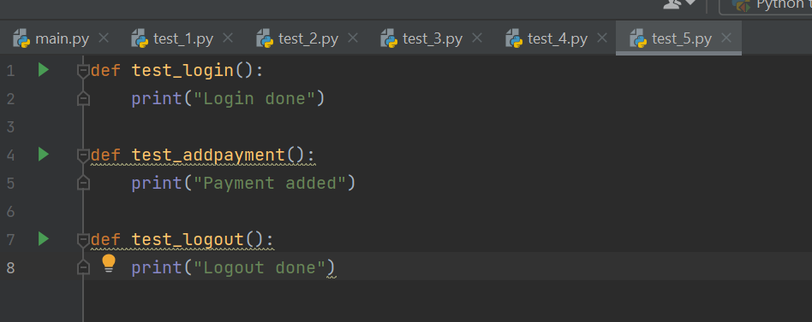

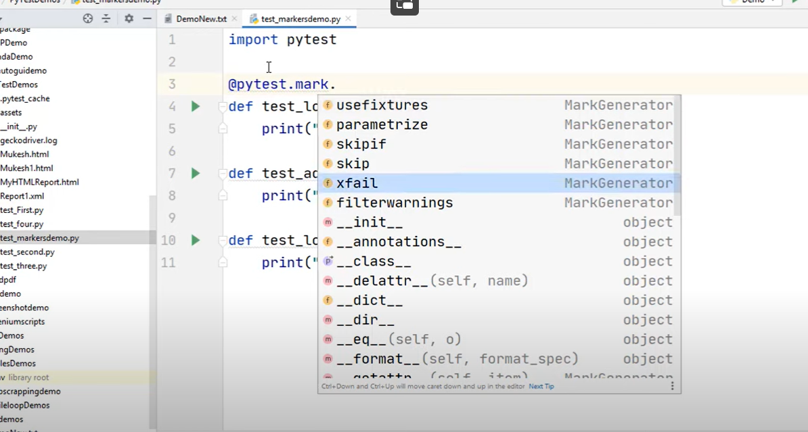

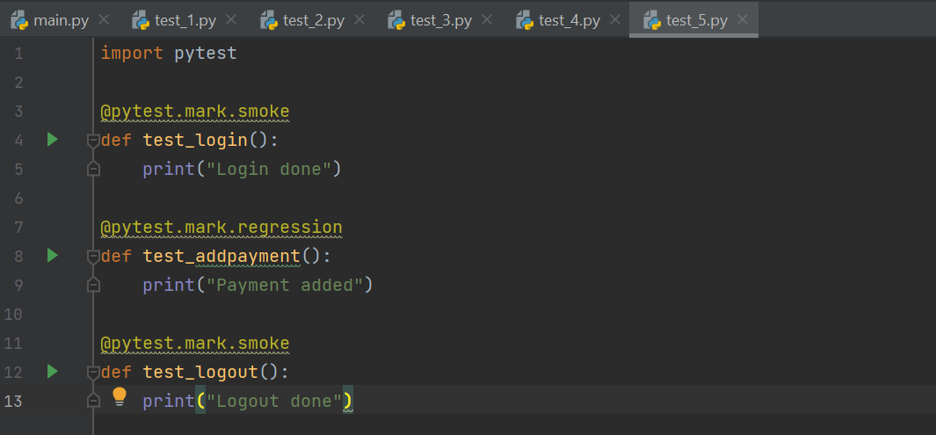

-m smoke used

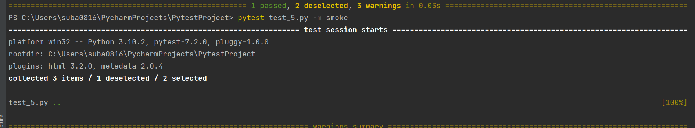

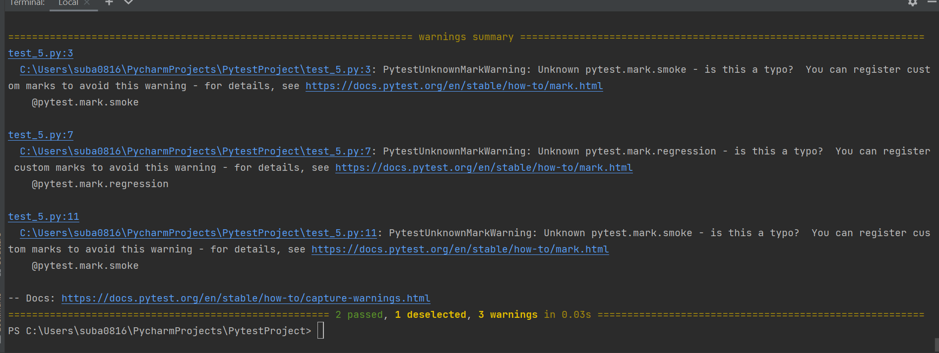

-m regression used

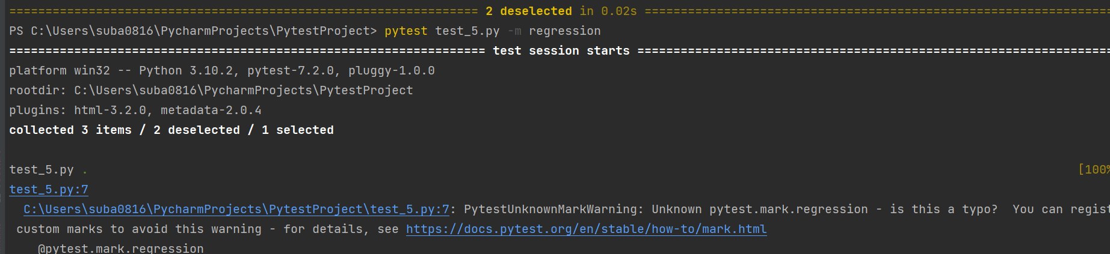

To run both

pytest test_5.py -m "smoke or regression"

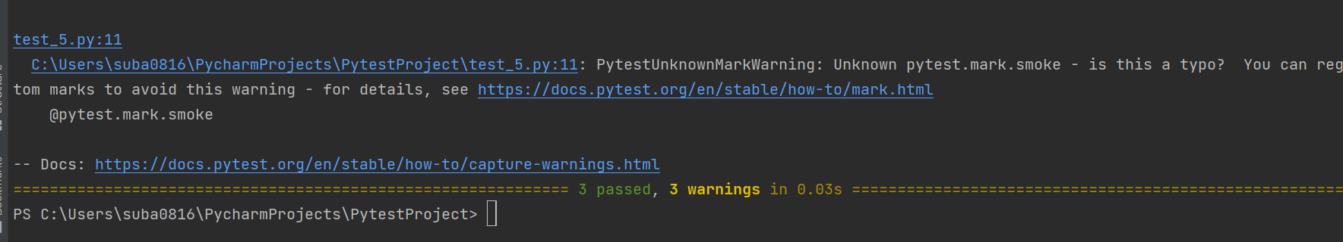

pytest test_5.py -m "smoke and regression"

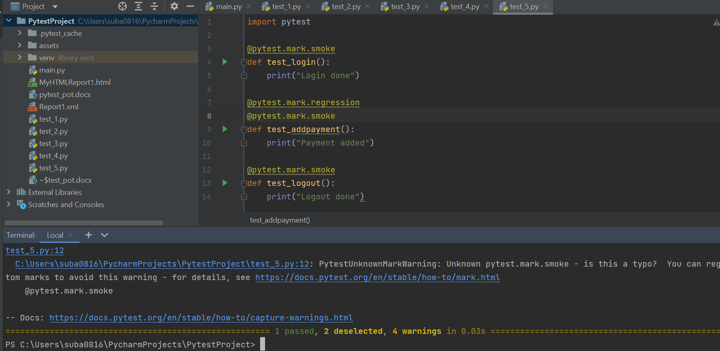

# Registering markers:

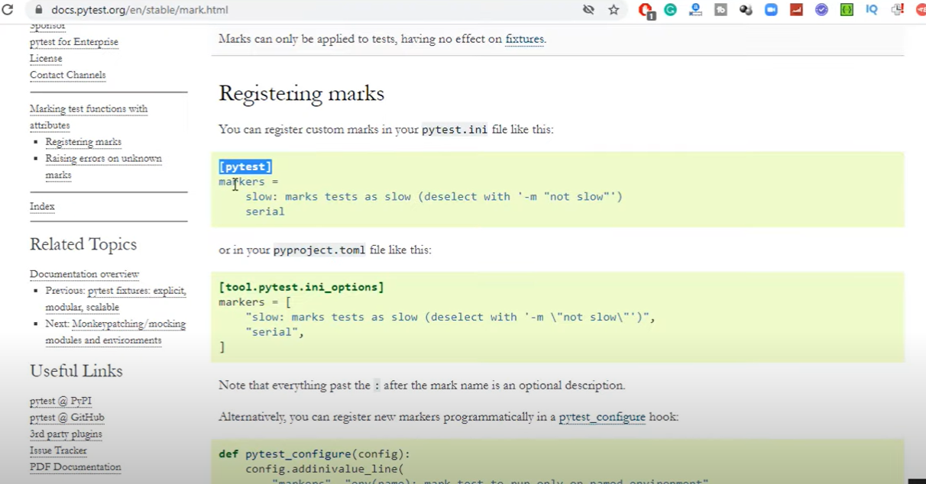

Registering markers for your test suite is simple:

*# content of pytest.ini*

**[pytest]**

markers =

webtest: mark a test as a webtest.

slow: mark test as slow.

Multiple custom markers can be registered, by defining each one in its own line, as shown in above example.

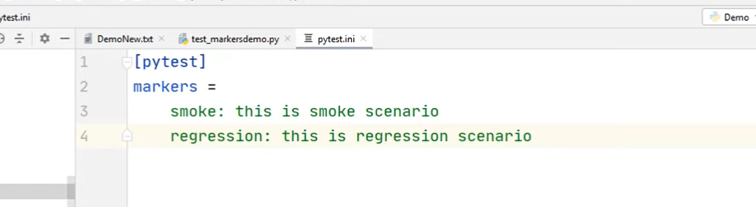

If we rerun test_5.py, warnings will not be seen anymore

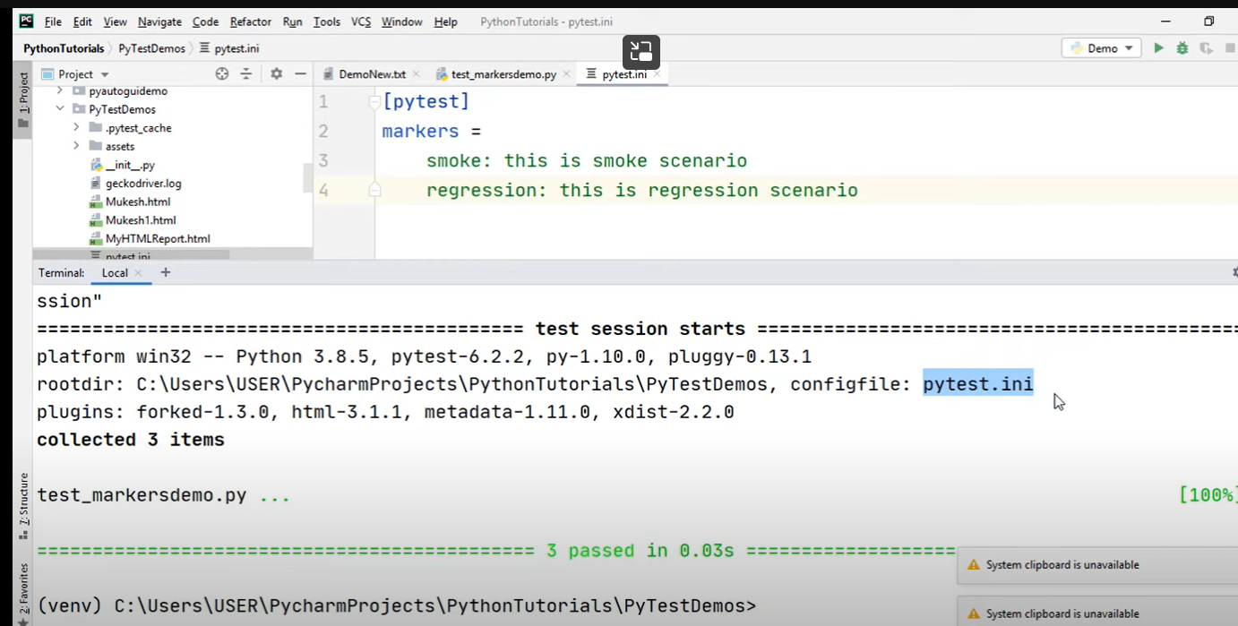

Add adopts in the ini file to add any options by default

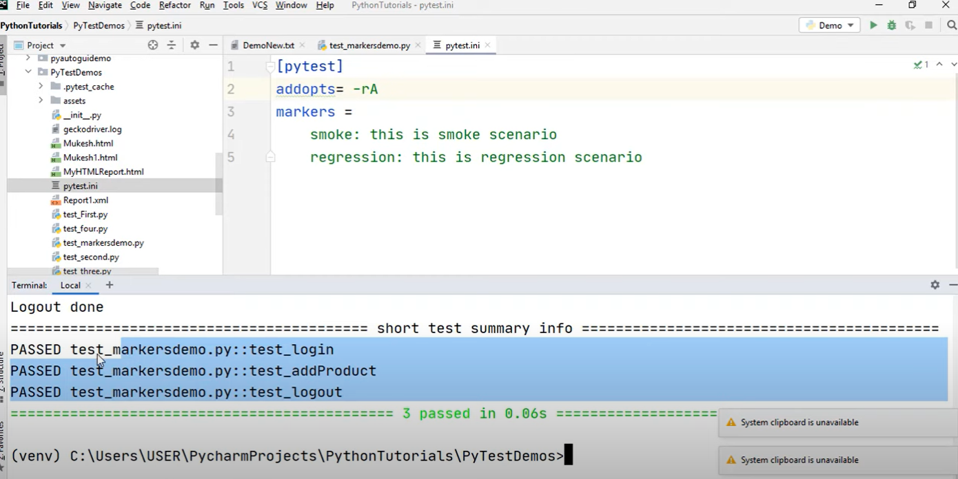

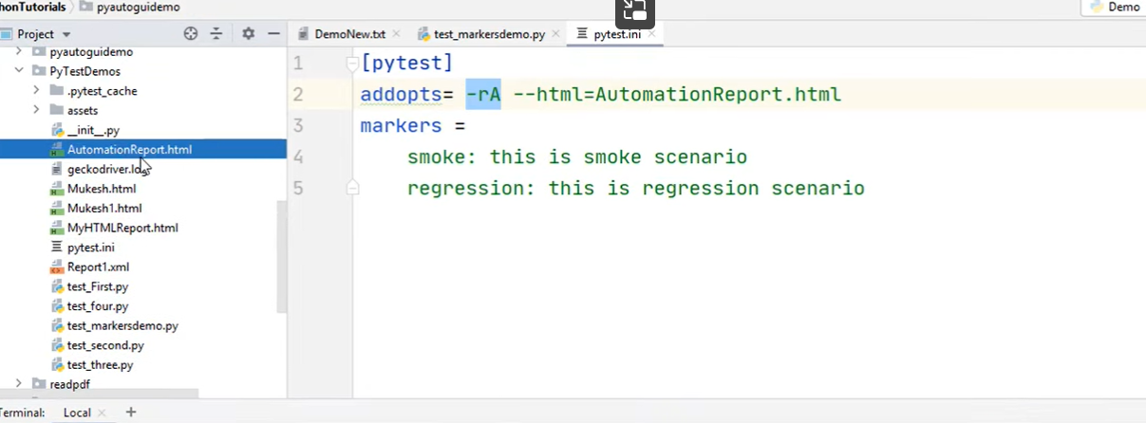

In-build markers:

Test_6:

skip

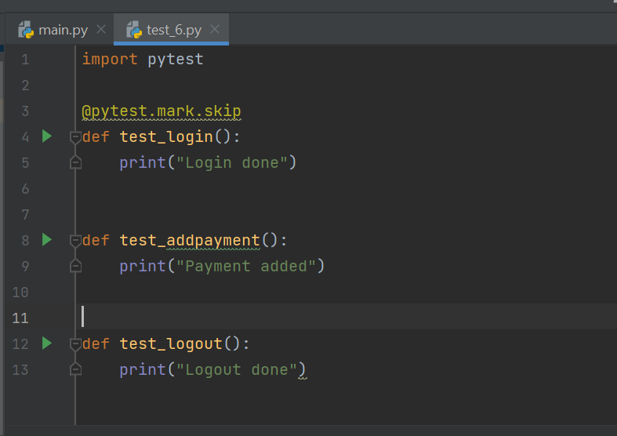

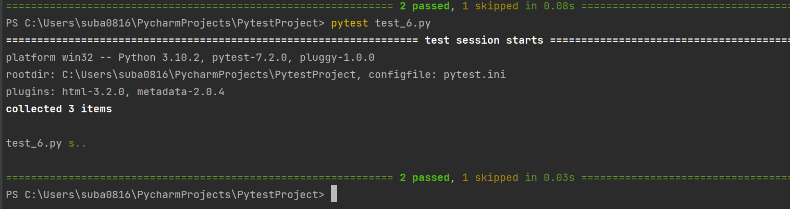

Skipif

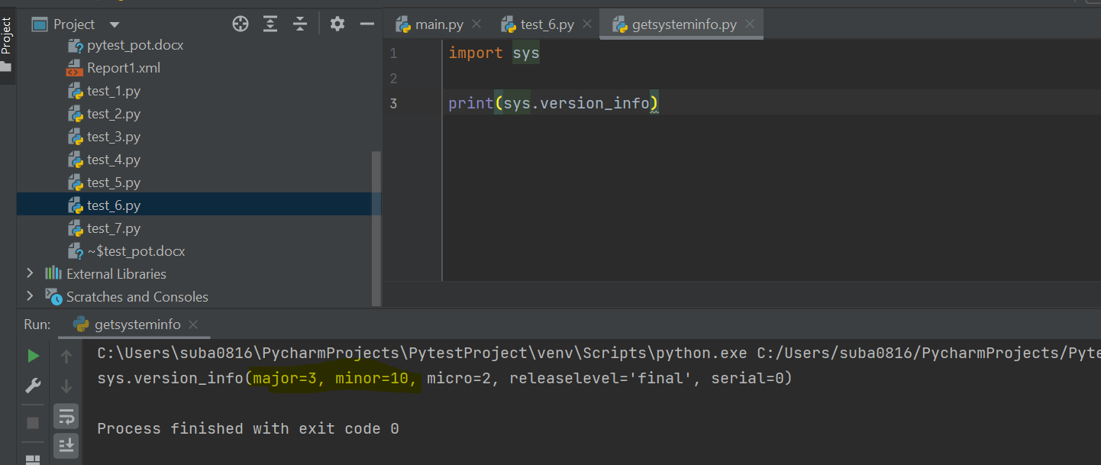

To fail 2nd case:

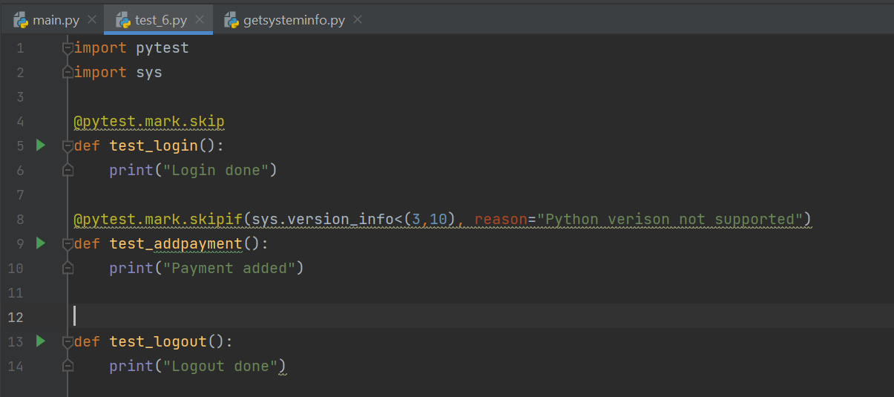

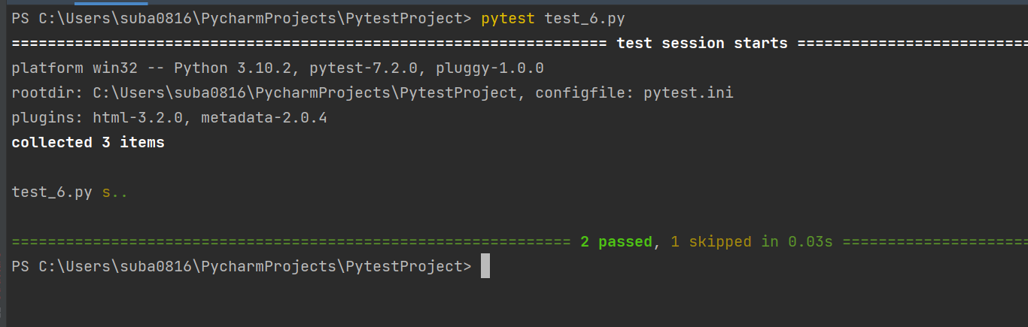

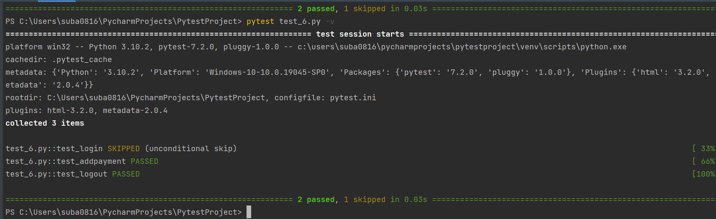

Xfail:

Expect test to fail for some reason

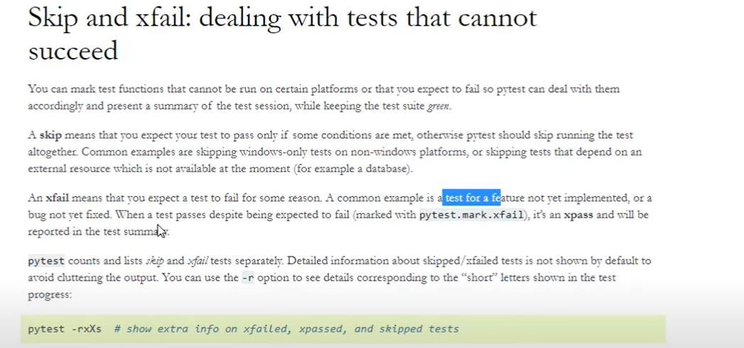

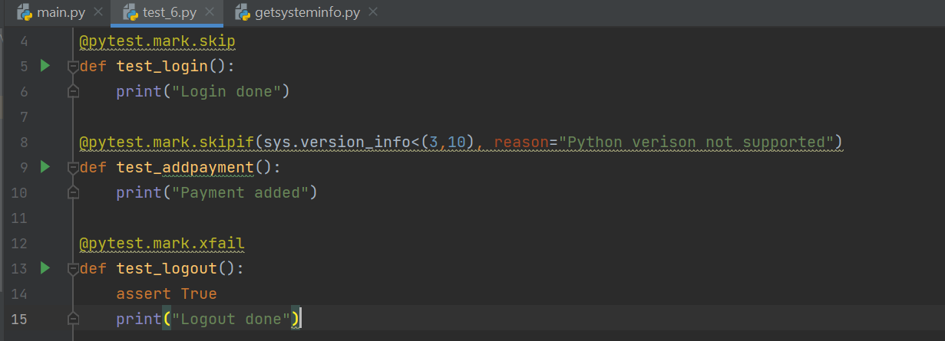

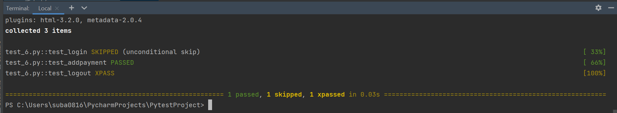

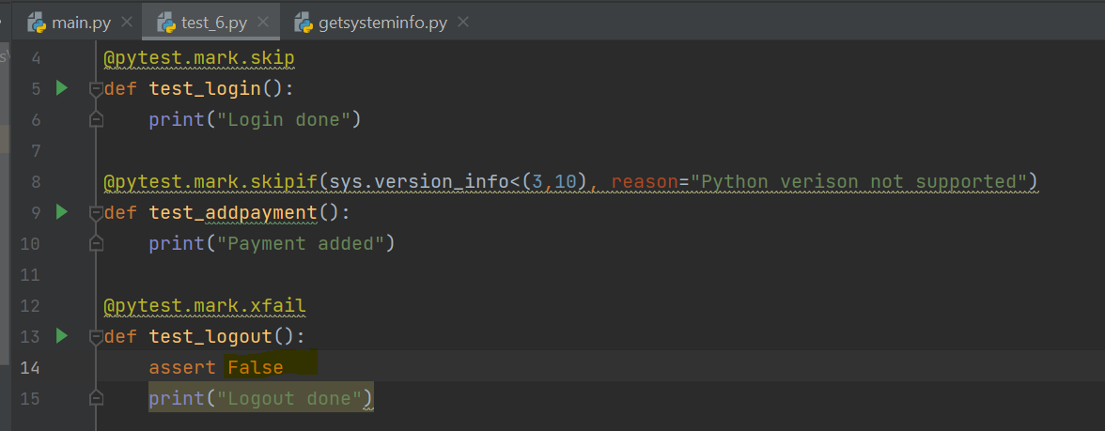

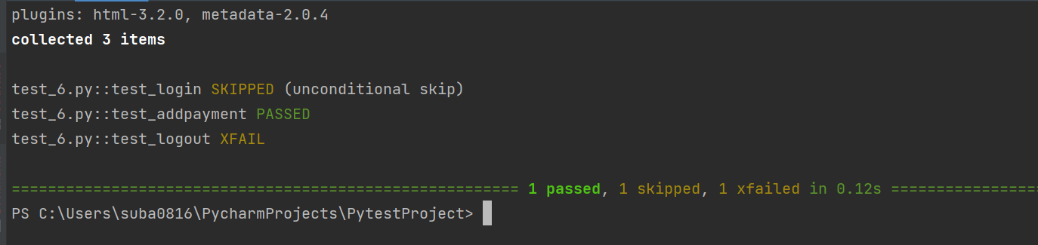

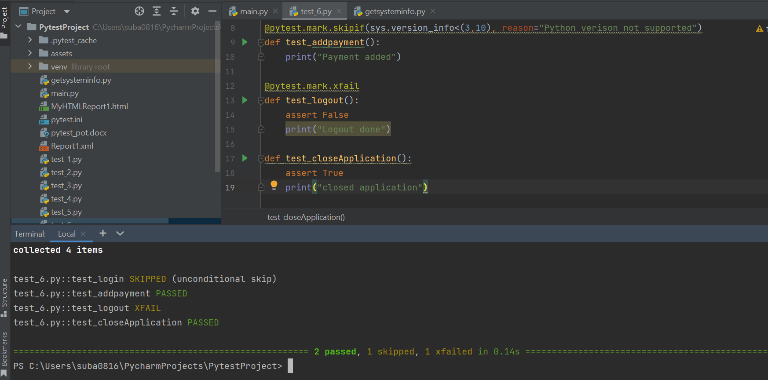

Marker parametrize:

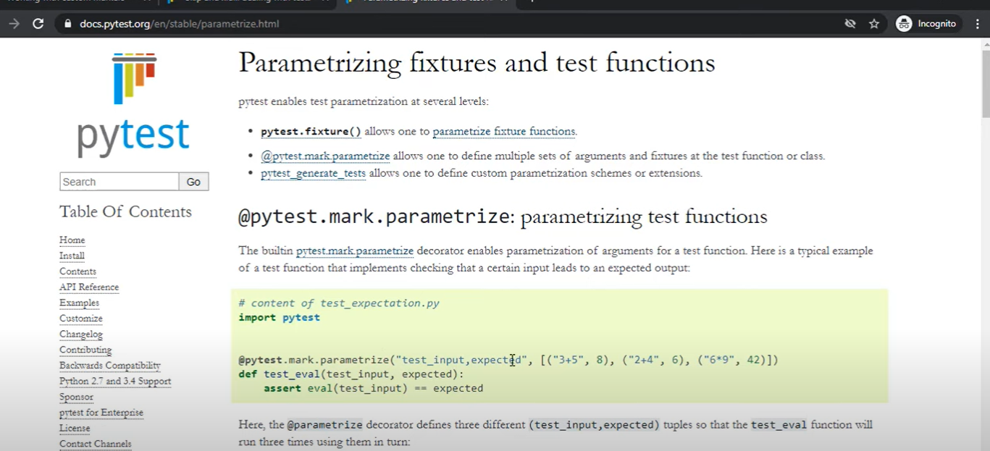

Test_7

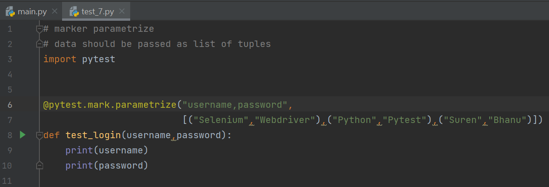

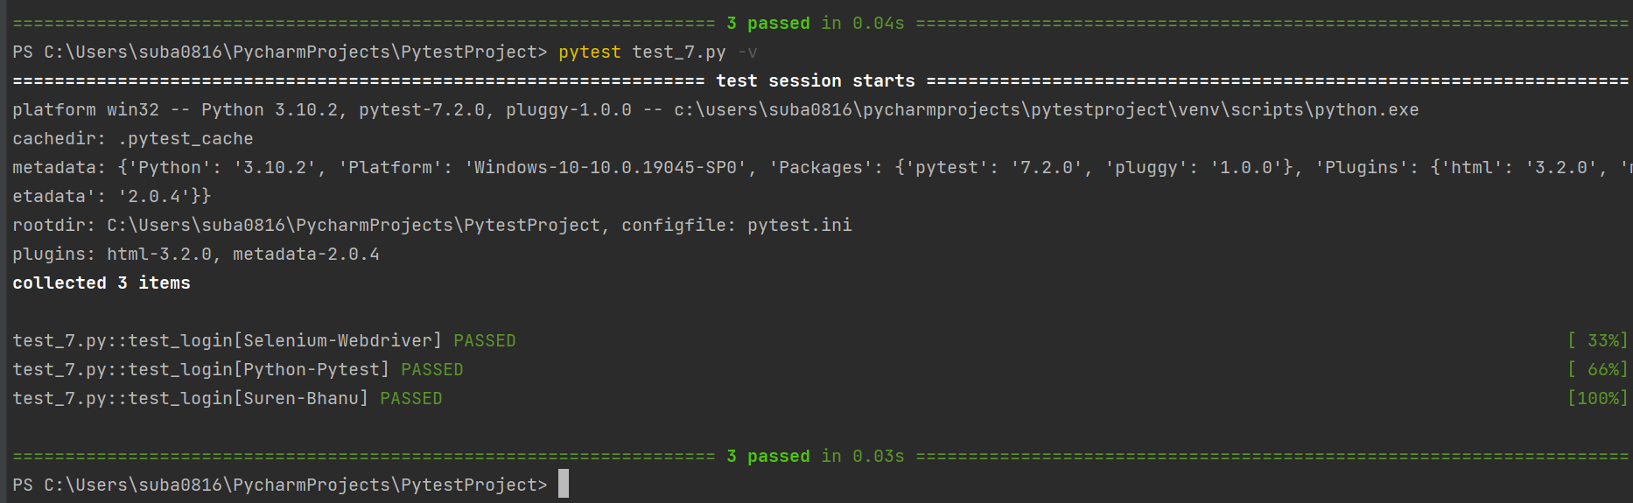

# Fixtures:

Fixtures will take care of pre & post conditions

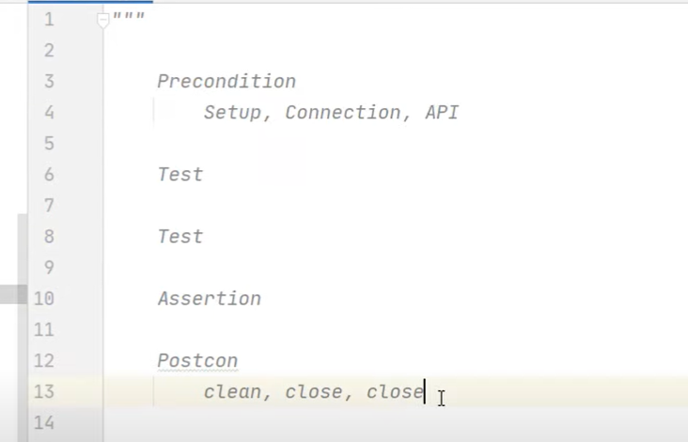

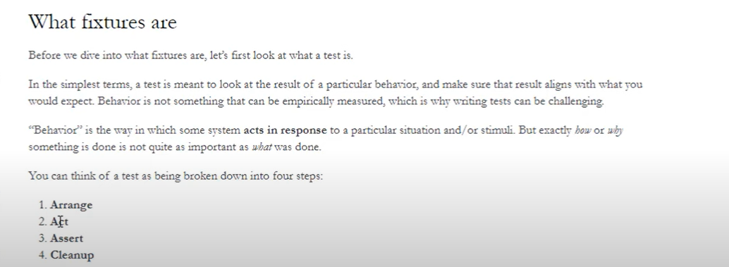

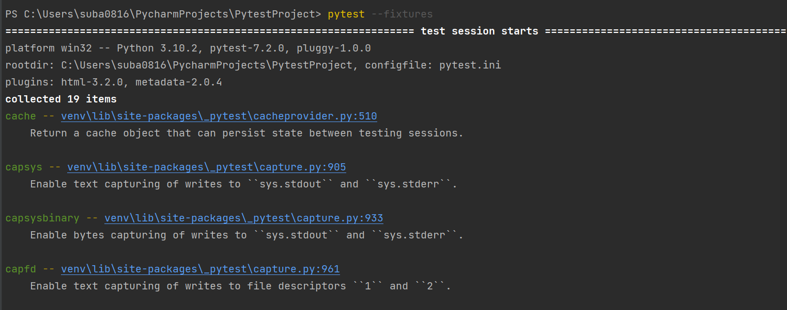

Test_8

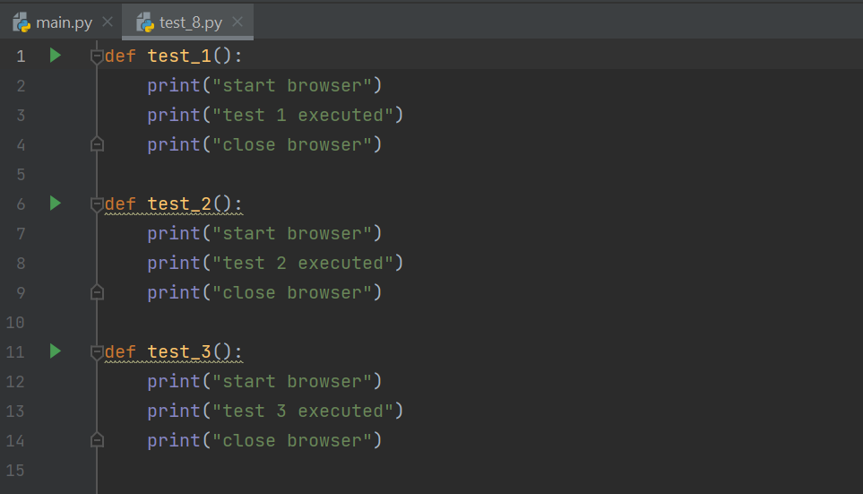

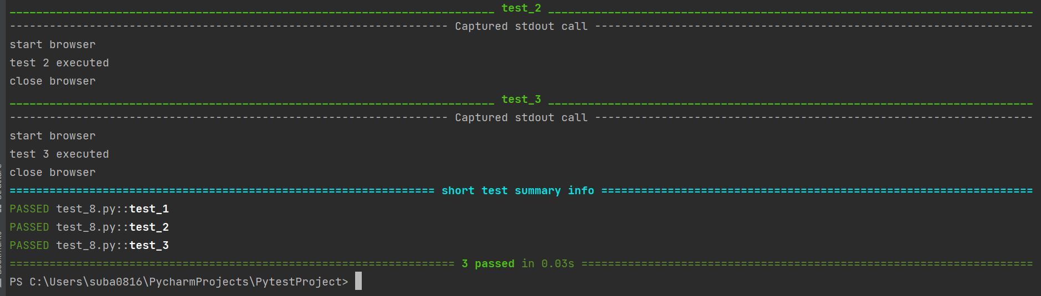

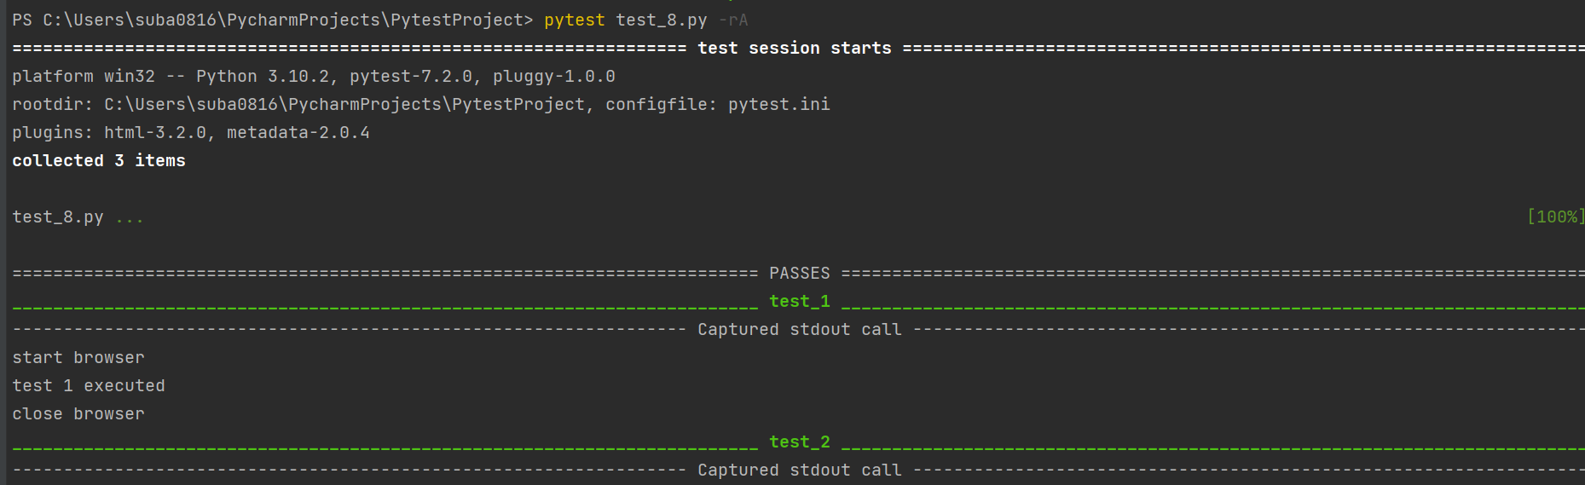

Some code is repeated, so need to place that in a fixture

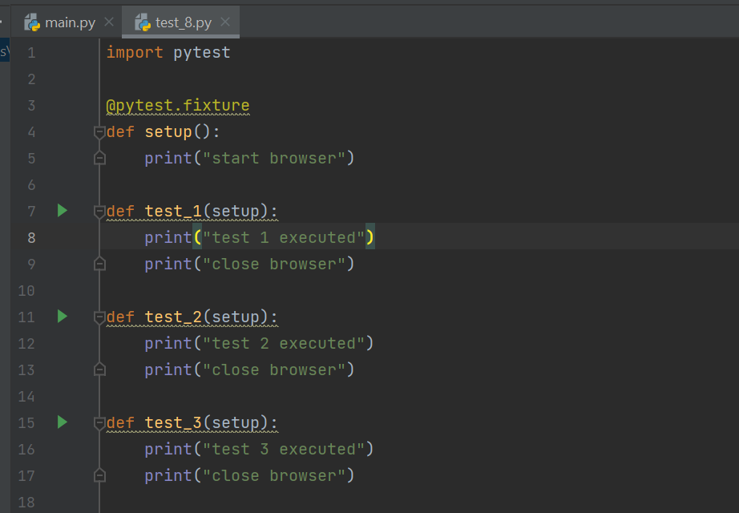

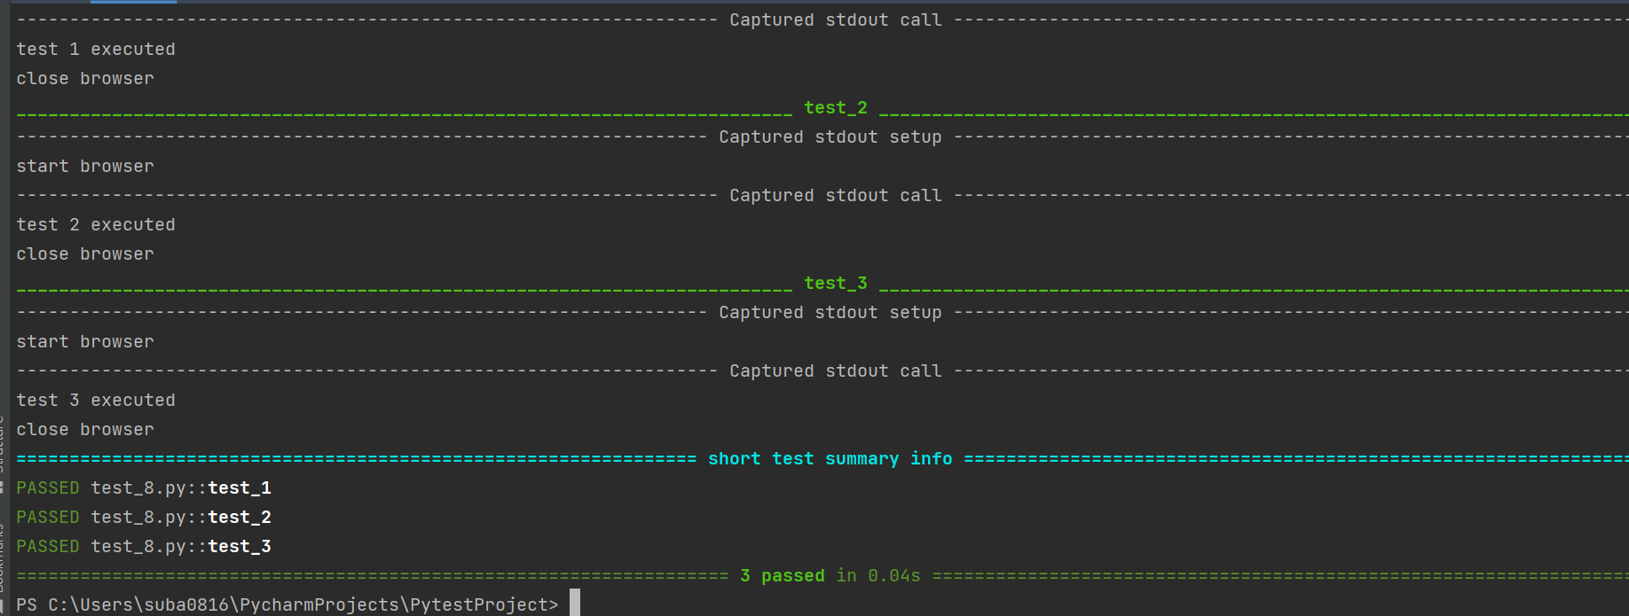

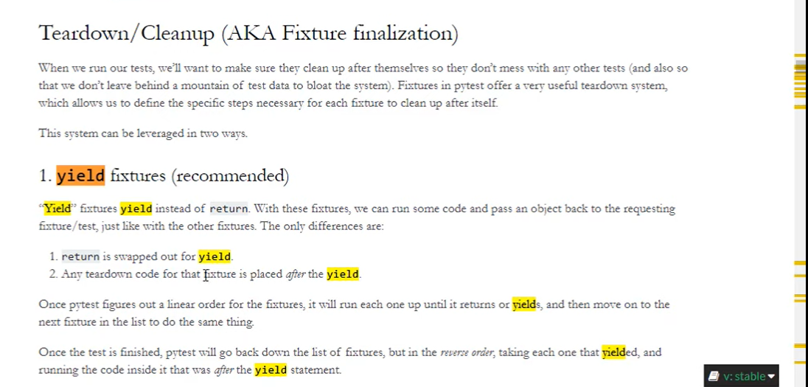

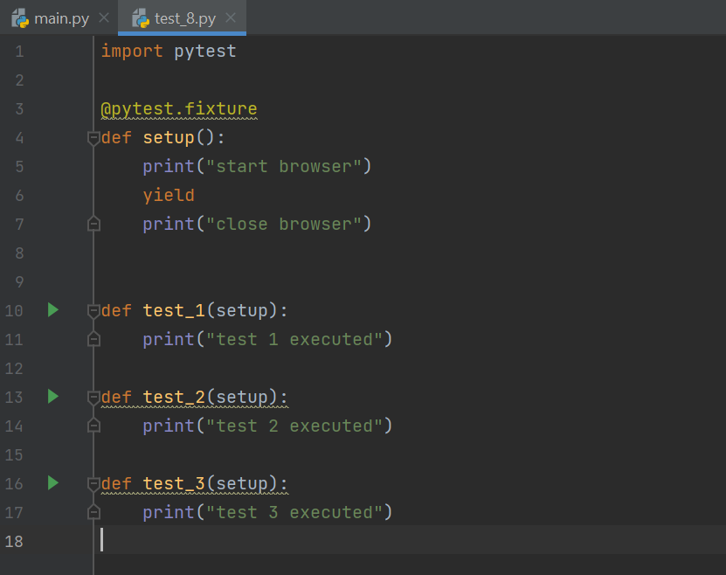

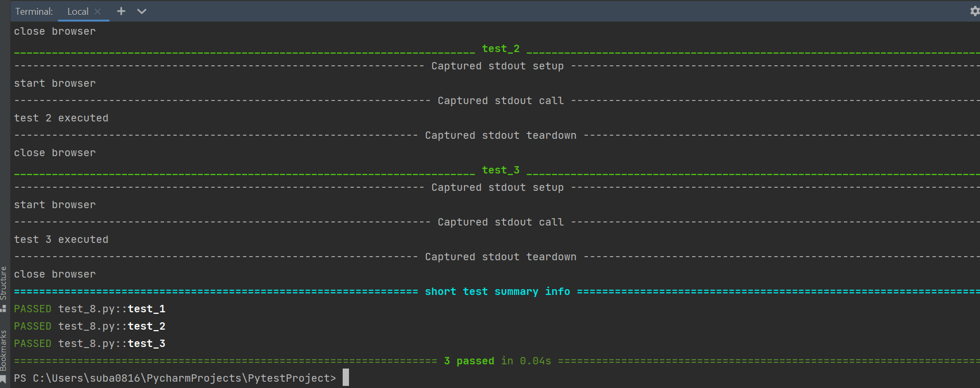

Use -s 🡪 to get what’s executing after yield

Setup before yield

Teardown/cleanup after yield

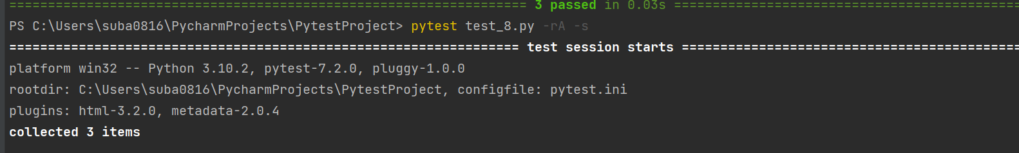

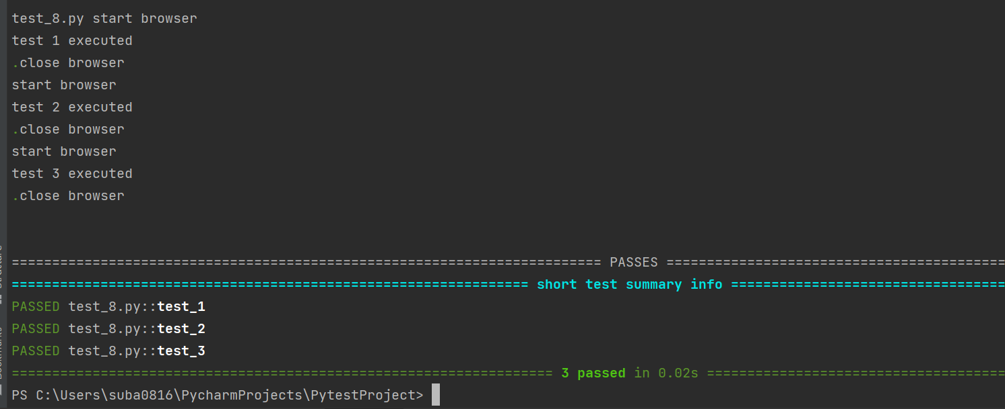

**Example with Selenium:**

Driver made global to call in all tests:

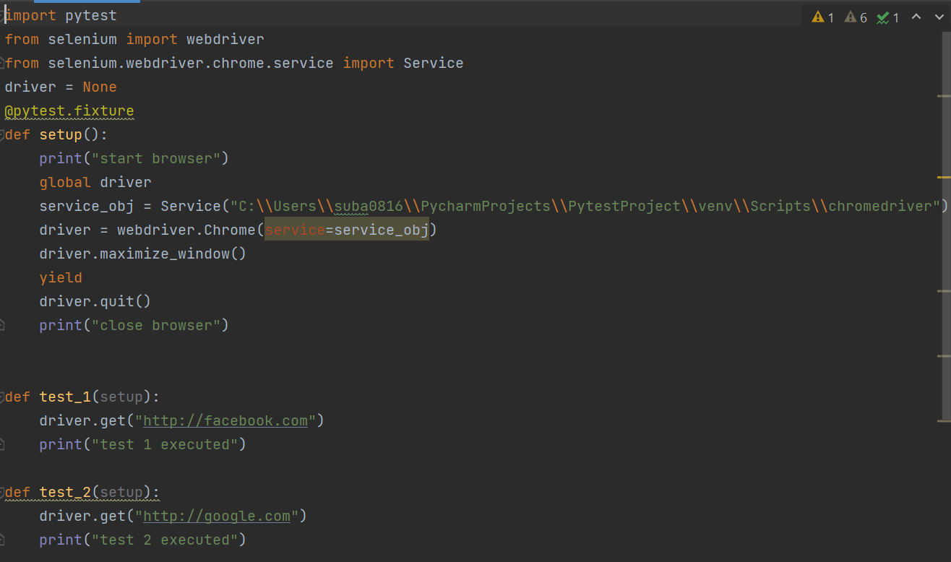

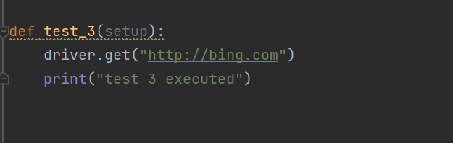

# Execute in parallel:

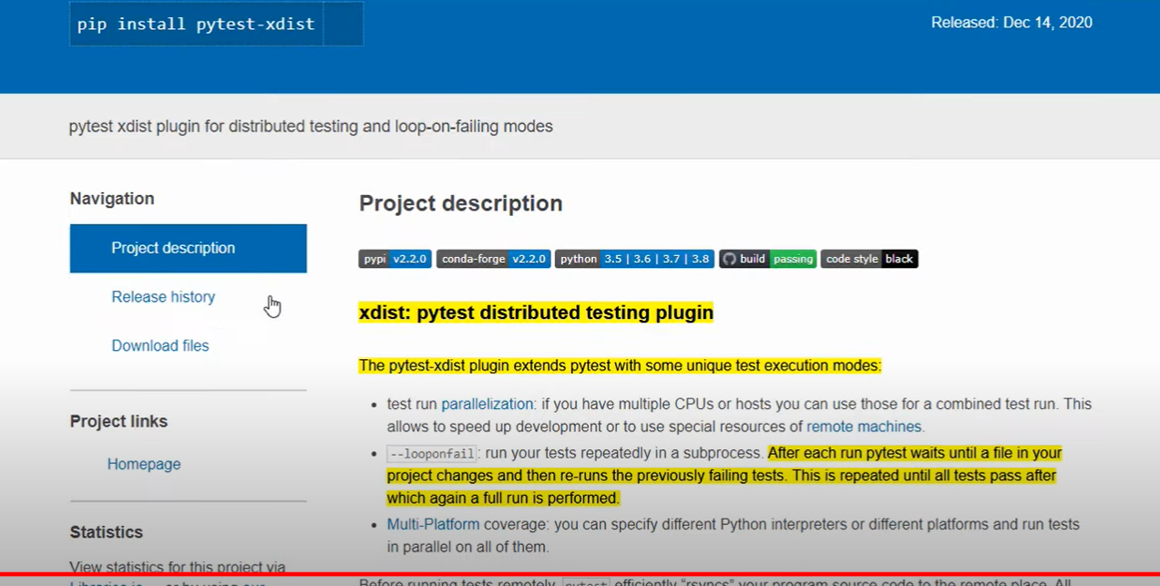

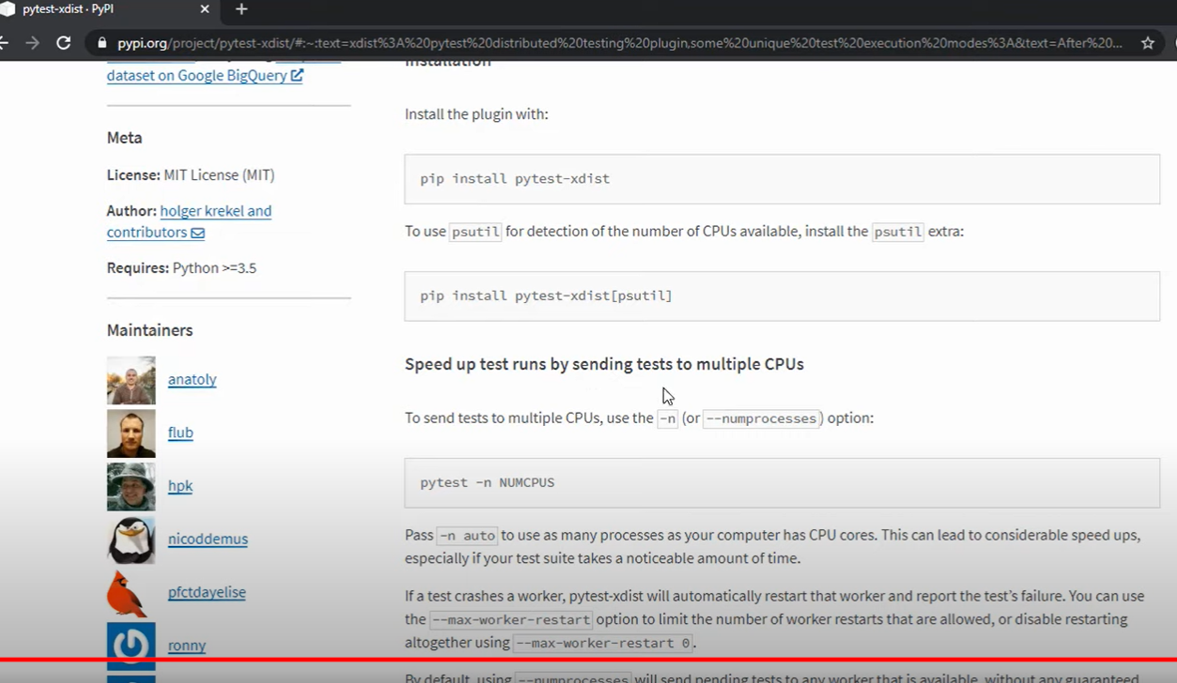

To run with 3 processes:

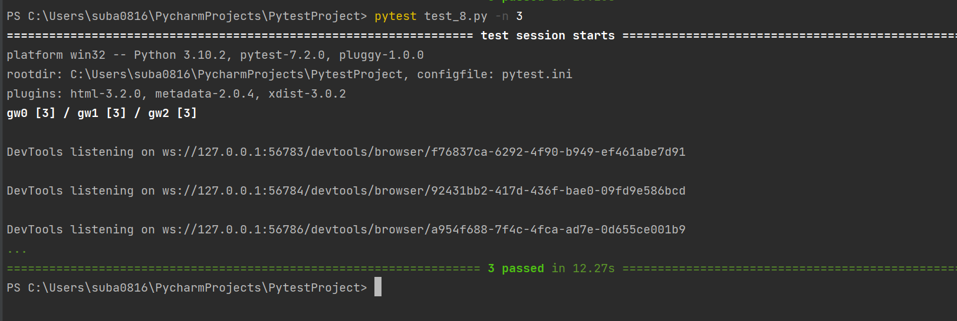

2 executed in parallel:

